A two-stage stochastic optimization for Smart Home Cybersecurity risk
Abstract
Smart homes (SH), with diverse and often insecure IoT devices, have become prime targets for cyberattacks, necessitating a substantial investment in security controls and informed decision-making in their implementation. This research proposes a two-stage stochastic optimization framework to optimize cybersecurity investments in decentralized SH architectures. The proposed model introduces Authentication as a fourth dimension (CIAA) into the existing CIA (Confidentiality-Integrity-Availability) triad, offering a holistic threat framework. For evaluation, we conducted a simulated experiment that demonstrates the robustness of the proposed models. Our models converge to the multi-layered defense strategy integrating system-specific countermeasures and node-specific measures. Findings show that the deterministic model underestimates risks and results in suboptimal resource allocation, while the stochastic model effectively addresses uncertain cyber risk. Thus, the study offers practical guidance for manufacturers, IT managers, and policymakers, emphasizing the need for risk-aware, adaptive security architectures in resource-constrained SH environments.
Keywords: Two-stage stochastic model; Cyber-risk assessment; Decentralized smart home (SH); Security countermeasures allocation

Introduction
The Internet of Things (IoT) is shaping home automation by facilitating seamless connectivity among technology enabled devices through the internet. Acting as a bridge IoT connects hardware devices, software systems, and cloud computing platforms into a unified ‘smart’ homes (SH) ecosystem. This enables the seamless data collection, and user behaviour analysis, providing personalized smart services such as enhanced security, convenience, comfort, energy efficiency and entertainment, thereby improving users’ quality of life (QoL). Reflecting this growing importance, global SH market is projected to grow to USD 116.4 billion by 2029 (Smart Home Market Size, Share & Trends Report, 2024).
However, the rapid proliferation of IoT devices has often prioritized functionality, time-to market, and performance over security consideration. This creates a heterogeneous and vulnerable infrastructure susceptible to attacks that compromise the confidentiality, integrity, and availability (CIA) security triad of data (U.S. Code, 2000; Zhang et al., 2025). A major security breach at Amazon's Ring LLC reported by Federal Trade Commission (FTC) in 2023 highlighted the unauthorized disclosure of customers' personal data, resulting in a $5.8 million consumer refund.
In response, researchers have proposed optimization-based cybersecurity investment models to allocate security countermeasures effectively. Zhang et al. (2018) proposed a constrained optimization model to minimizes the losses from CIA security breaches and allocate security controls for the IT infrastructure. Khouzani et al. (2019) proposed a multi-objective optimisation model for optimal cyberdefence investment given a portfolio of security controls. To analyze the impact of risk-aversion, Mitev et al. (2019) presented the attacker-defender scenarios where a defender aims to select security countermeasures against CIA attacks. However, these models failed to capture authentication breach, even though such failure damages the inter-connected decentralized SH network leading to operational downtime, financial losses, compromises privacy and security, and reputation damage. Moreover, prior studies assumed static compromise probabilities, overlooking dynamic impact of security countermeasures implementation. In this regard, Zhang et al. (2023) formulated the CROSS framework integrating a multi-objective bi-level two-stage optimisation model which selects optimal security controls to mitigate cyber-attacks in SH supply chain. To consider for uncertainty, Keith et al. (2024) modelled the two-stage stochastic programming problem for analyzing the cyber-risk with specific focus on semiconductor wafer fabrication facilities. Recently, Zhang et al., (2025) focussed their study on the internal and external cyber-risks identification specially in smart homes but failed to consider the decentralized architecture of SH and quantify the cyber-risks.
To address these gaps, this study investigates two major research questions: how can traditional cybersecurity threat models (CIA triad) be effectively expanded to more holistically capture the smart home attack surface? and, how do security countermeasures costs and potential financial losses from breaches influence the optimal cybersecurity investment strategy? To address these questions, we propose a two-stage stochastic approach that extend the existing CIA based model by introducing authentication as fourth breach dimension, resulting in CIAA framework. In the first stage, the model minimises the cyber losses from CIAA breaches while accounting for the security countermeasure’s implementation costs. Additionally, we categorized the countermeasures into system-specific and node-specific categories. In the second stage, a simulation-based approach is utilized to analyze the breach impact and allocate optimal security countermeasures. The robustness of the proposed model is tested using the Gurobi solver in a Python environment.
The manuscript is organized in six sections as follows. Section 2 presents the scholarly works and identifies research gaps. Section 3 highlights the model formulation, including variables, its definitions, functions, and constraints. Section 4 reports numerical experiment and countermeasure allocation assessment. Section 5 provides implications of the study. In section 6, conclusion with limitations and scope for future research is presented.

Literature Review
  - Risk of security breaches in Decentralized SH architecture
A security breach is defined as an unauthorized access, disclosure, or compromise of a system’s data, or the violation of its security policies (Gordon et al., 2011). Bastos et al. (2018) investigates different security challenges existing in SH devices in different architectural layer under security breaches. This study highlights that the edge layer acts as an easy vulnerable point for intrusion, and is susceptible to attacks such as eavesdropping, botnet attacks, sniffing attacks, etc. Attackers exploit the vulnerable edge devices to access private information by embedding malicious devices in the vicinity of authentic ones within the network (Fakhri and Mutijarsa, 2018). Further, fog layer (gateways and central hubs) faces distinct security threats, mainly triggered by data congestion impact the data integrity and authenticity, which result in receiving either no information or misinformation. In such context, the attack at gateway including Denial of Service (DoS) attack, Man-in-the-Middle (MITM), or gateway attacks demolishes the critical link between sensors and the internet service provider (ISP) (Touqeer et al., 2021). Next is the cloud layer, which manages sensitive data and critical infrastructure, a high-value target for attackers. For instance, an attack on smart meters within a home can result in authorized access and compromise of user’s power consumption usage data, posing a privacy threat due to inadequate protection (Wang, 2019). Attackers also target the SH communication channels (wired and wireless) which takes place via X10, ZigBee, and Z-wave. Attackers remotely interrupt these communication channels leading to financial losses for users.
However, the existing body of literature lacks focused analysis on different types of security breaches, particularly in the SH environment. Zhang et al. (2018) studied CIA security breaches and subsequently analyze their impact on IT infrastructure. The study examines the authentication embedded in integrity breach as a single breach type, ignoring its independent impact. By employing threat modeling and simulation-based techniques, this research aims to analyse the consequences of four major types of security breaches and extend the existing studies: Confidentiality breach, integrity breach, availability breach, and authentication breach (ACIA).
  - Economics of security investment and Optimal selection of countermeasures
With the rising cyber threats, scholars have shifted their focus on analyzing the security threats economically and formulating optimization models for risk/cost minimization pertaining to cyber risk planning. Schilling and Werners (2016) formulated a mixed-integer linear programming model with IT baseline protection catalogues from the German Federal Office for Information Security. The model aims to select effective safeguards which can protect IT infrastructures and its systems. Further, Wang (2019) proposed cyber breach probability and minimizes the cybersecurity investments under security breaches. However, these studies model the security threat in a deterministic setting, and ignored the associated uncertainties, and countermeasure’s effectiveness.
To address the uncertain parameter’s estimation, the literature witnesses the extension of deterministic models to stochastic models. Zhang et al. (2018) formulated a deterministic model and further framed two-stage stochastic model to minimize the losses from different security breaches and the total control deployment investment. Paul and Zhang (2021) proposed a two-stage stochastic programming framework that models the interactions between a firm, a government regulator, and an attacker to support long-term cybersecurity risk planning under uncertainty. Sawik (2022) presented a mixed-integer programming model for optimizing cybersecurity investment across a supply chain. These studies highlight the lack of proper models to address the issues existing in the security postures which is usually due to information asymmetry and privacy concerns. Sawik and Sawik (2022), presented a portfolio optimization approach for selecting a mix of security controls for a given budget, treating security controls as financial assets. Shukla et al. (2023) formulated a multi-objective optimization framework that aims to maximize security, minimize cost, and maximize operational performance. Kaur et al. (2024) framed a multi-objective optimization model for cybersecurity investment to enhance the overall cyber resilience of a digital supply chain. However, quantifying the overlapping effects between different security controls in a portfolio becomes complex with the increase in the number of suppliers and potential investment options, making it computationally heavy for large-scale supply chains. Zheng et al. (2025) introduced a Unified Robust Simulation-based Optimization (URSO) framework involving costly simulations, constraints, and uncertainty under cyber-attacks. In recent studies, Grass et al. (2025) proposed a two-stage stochastic model intended to strengthen the cyber defense capability of healthcare providers, and selecting the effective countermeasures against cyber-attacks. Jungebloud et al. (2025) proposed a unified framework to identify structural threat and analyze mean time to compromise (MTTC) behaviour of attackers through simulation.
  - Gaps and contributions
The review of scholarly works reveals a significant focus on theoretical concepts, but the integration of comprehensive threat modeling with cost-effective, robust resource allocation remains underdeveloped, presenting several critical gaps. First, although CIA attacks have been modelled extensively, authentication is frequently subsumed under integrity rather than treated as a distinct dimension, leaving a gap in holistic threat assessment (Zhang et al., 2018). Addressing this gap, the present study integrates authentication as a critical fourth dimension into the CIAA framework, extending traditional CIA models to systematically examines the criticality and persistence of authentication attacks in SH critical infrastructures.
Second, existing literature lack a structured model for minimizing the total cost of security implementations across different architectural levels (Bastos et al., 2018). Recent research often treats countermeasures in isolation without a unified cost-benefit analysis. Our work advances the literature by formulating an integrated optimization model that minimizes the total cost of deploying countermeasures in both system-wide and node-specific settings, providing a practical resource allocation strategy for decentralized infrastructures.
Third, while deterministic and stochastic optimization models have been widely applied in different IoT domains, their application to the decentralized, resource-constrained, and dynamically evolving threat environment of SH remains underexplored. Existing studies often fail to capture the risk profile of residential IoT systems, which involve heterogeneous devices, multi-layer infrastructure (edge-fog-cloud), and user’s limited expertise (Zhang et al., 2018; Zhang et al., 2023). This study addresses these limitations by proposing a two-stage stochastic optimization model, incorporating real-world uncertainties through simulation model explicitly in SH context to derive resilient and cost-effective cybersecurity investment strategies.
- Model formulation
  - Problem statement
A decentralized SH infrastructure typically consists of three layers. The edge layer consists of resource-constrained, heterogeneous IoT devices as edge nodes (like thermostat sensors, motion sensors, etc). The fog layer comprises of intermediary nodes as central hubs (such as Alexa, Google Wifi etc, and routers as application servers) and perform functions such as controlling, networking, computing, and storing. Next is cloud layer which comprise of database servers (offered by Google, Amazon etc) and provide large storage and computing capabilities via remote servers. These layers communicate and transact information (or user’s request) through wireless or wired transmission using different transaction types. Higher dependence on lightweight IoT devices with limiting capabilities, decentralized SH architecture is highly exposed to cyber risks, necessitating investment in suitable security countermeasures (Zhang and Malacaria, 2025). However, implementing security measures can only reduce the breach probability, but none of them assures complete security (Gordon and Loeb, 2002). So, when combined, these countermeasures can offer greater extent of security against the security breaches (Hausken,
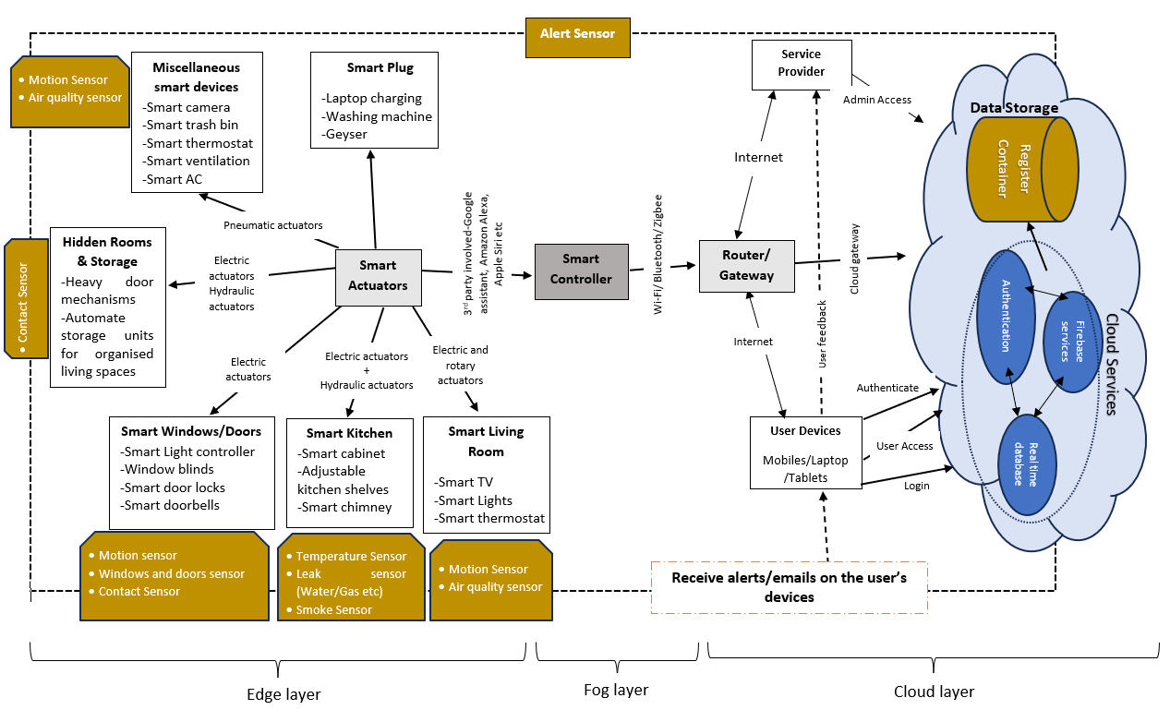
Figure 1. Decentralized SH architecture
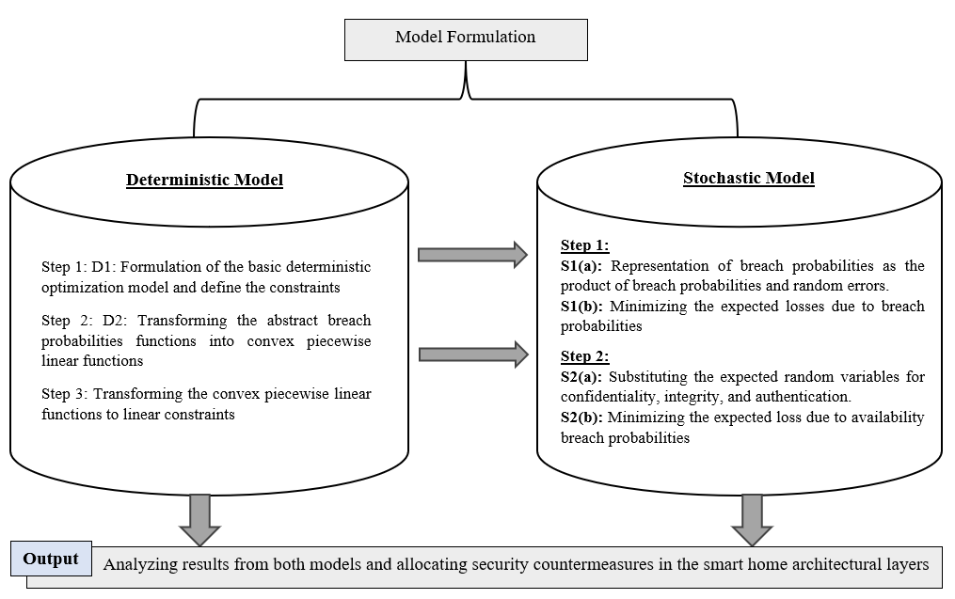
Figure 2. A conceptual framework of the proposed model.
2006). Accordingly, this study categorizes security countermeasures into system-specific and node specific countermeasures.
Definitions of different key terms used in our study are provided in Appendix A. The probabilities of breach failures are subject to countermeasures type considered for the study. To increase availability or scalability, a single SH architecture (Figure 1) is considered. Figure 2 highlights the overall conceptual framework for the study.
  - Notations and Model Formulation
The well-defined sets, input parameters, and variables used are given in Table 1.
Assumptions
Considering the impact of the different security breaches, we make the following assumptions to ensure our models remain manageable while minimizing the loss of generality (derived from Zhang et al., 2018).
Assumption 1. The type of transactions considers equal processing time at any node device in respective system layers. Here, the processing capacity is denoted by transactions per minute.
Assumption 2. The transaction rate function $g_{l}\left({\left[P_{d}^{avail}\right]}_{dϵN_{l} }, {\left[Y_{d}^{l}\right]}_{dϵN_{l} }\right)$ is separable under availability breach probability ($P_{d}^{avail}$) such that $g_{l}\left({\left[P_{d}^{avail}\right]}_{dϵN_{l} }, {\left[Y_{d}^{l}\right]}_{dϵN_{l} }\right)=-\sum_{\begin{aligned}dϵN_{l} \\ lϵL\end{aligned}}{h_{l}^{d}\left(P_{d}^{avail}, Y_{d}^{l}\right)+}ρ_{l}$ , where ρ denotes the processing capacity of layer ‘l’ and $h_{l}^{d}\left(P_{d}^{avail}, Y_{d}^{l}\right)$ represents the expected reduction in the processing capacity of the nodes ‘d’ in the layer ‘l’, which is a convex and monotonically non-decreasing function for the given $P_{d}^{avail}$ at node d. $Y_{d}$ denotes the capacity of node d.
Assumption 3. The breach probabilities $P_{p}^{conf}\left({\left[x_{i}^{S}\right]}_{i∈S} , {\left[x_{dlj}^{Ns}\right]}_{j∈N}\right)$, $P_{p}^{int}\left({\left[x_{i}^{S}\right]}_{i∈S} , {\left[x_{dlj}^{Ns}\right]}_{j∈N}\right)$, $P_{p}^{avail}\left({\left[x_{i}^{S}\right]}_{i∈S} , {\left[x_{dlj}^{Ns}\right]}_{j∈N}\right)$, and $P_{p}^{auth}\left({\left[x_{i}^{S}\right]}_{i∈S} , {\left[x_{dlj}^{Ns}\right]}_{j∈N}\right)$ for each node ‘d’ are convex piecewise linear functions under the security settings ${\left[x_{i}^{S}\right]}_{i∈S} , {\left[x_{dlj}^{Ns}\right]}_{j∈N}$.

Table 1 List of sets, input parameters, and decision variables.
 | Notations | Descriptions
 | Sets
 | K | Index set of types of transaction
 | L | Index set of layers (i.e., edge, fog, and cloud layers)
 | $$L_{k}$$ | Index set of layers used in processing transaction of type k ϵ K
 | $$N_{l}$$ | Index set of nodes consisting of processing devices (units) in layer l ϵ L
 | N | Index set of nodes in different layers.
 | S | Index set of the system-specific security setting types
 | Ns | Index set of node- specific security setting types
 | Input parameters
 | $t^{avail}$ | Average time to restore the system due to an availability breach
 | $$Y_{d}^{l}$$ | Capacity of node d of layer l, measured in transactions/min
 | $$ρ_{l}$$ | Processing capacity of the system layers l, measured in transactions/min
 | $$π_{kl }$$ | No: of sub-transactions generated from each transaction type k ϵ K at the system’s layer l ϵ L
 | $$D_{k}^{SysNormal}$$ | Desired transaction rate of transaction type k ϵ K (measured in transactions per minute) when the processing capacities of servers are optimally realized
 | $$C_{k}^{avail}$$ | Unit cost of transaction loss rate of transaction type k ϵ K, due to an availability breach
 | $$C_{i}^{S}$$ | Unit cost of system- specific security setting type i ϵ S
 | $$C_{dlj}^{Ns}$$ | Unit cost of nodes-specific security setting type j ϵ Ns used at node d of layer l
 | $$γ_{d,l}^{conf}$$ | Average loss amounts due to confidentiality breach at node d of layer l
 | $$γ_{d,l}^{int}$$ | Average loss amounts due to integrity breach at node d of layer l
 | $$γ_{d,l}^{auth}$$ | Average loss amounts due to authentication breach at node d of layer l
 | $η_{conf,m}$, $η_{int,m}$, $η_{avail,m}$, $η_{auth,m}$ | Coefficients of total security cost terms in the m^{th} equation that are piecewise linear approximations of confidentiality, integrity, availability, and authentication breach probabilities as a function of expenses.
 | $ξ_{conf,m}$, $ξ_{int,m}$, $ξ_{avail,m}$, $ξ_{auth,m}$ | Intercept terms in the m^{th} equation that are piecewise linear approximations of confidentiality, integrity, availability, and authentication breach probabilities as a function of total security cost.
 | $w_{conf}$, $w_{int}$, $w_{avail}$, $w_{auth}$ | No: of piecewise linear approximation segments each for confidentiality, integrity, availability, and authentication breach probabilities.
 | $Δ_{conf}$, $Δ_{int}$, $Δ_{avail}$, $Δ_{auth}$ | Random errors for each estimate of confidentiality, integrity, availability, and authentication breach probability.
 | θ | Vector of $Δ_{conf}$, $Δ_{int}$, $Δ_{avail}$, $Δ_{auth}$
Functions
$$P_{d,l}^{conf}\left({\left[x_{i}^{S}\right]}_{i∈S} , {\left[x_{dlj}^{Ns}\right]}_{j∈N}\right)$$ |  | Confidentiality breach probability at node d of layer l, given countermeasures ${\left[x_{i}^{S}\right]}_{i∈S} , {\left[x_{dlj}^{Ns}\right]}_{j∈N}$
$$P_{d,l}^{int}\left({\left[x_{i}^{S}\right]}_{i∈S} , {\left[x_{dlj}^{Ns}\right]}_{j∈N}\right)$$ |  | Integrity breach probability at node d of layer l, given countermeasures ${\left[x_{i}^{S}\right]}_{i∈S} , {\left[x_{dlj}^{Ns}\right]}_{j∈N}$
$$P_{d,l}^{avail}\left({\left[x_{i}^{S}\right]}_{i∈S} , {\left[x_{dlj}^{Ns}\right]}_{j∈N}\right)$$ |  | Availability breach probability at node d of layer l, given countermeasures ${\left[x_{i}^{S}\right]}_{i∈S} , {\left[x_{dlj}^{Ns}\right]}_{j∈N}$
$$P_{d,l}^{auth}\left({\left[x_{i}^{S}\right]}_{i∈S} , {\left[x_{dlj}^{Ns}\right]}_{j∈N}\right)$$ |  | Authentication breach probability at node d of layer l, given countermeasures ${\left[x_{i}^{S}\right]}_{i∈S} , {\left[x_{dlj}^{Ns}\right]}_{j∈N}$
$$g_{l}\left({\left[P_{d}^{avail}\right]}_{dɛN_{l} }, {\left[Y_{d}^{l}\right]}_{dɛN_{l}}\right)$$ |  | Function for computing expected transaction rate for system at layer l, for the given vectors [$P_{d}^{avail}]$ and [$Y_{d}]$ for the nodes in layer l
 | $$h_{l}^{d}\left(P_{d}^{avail}, Y_{d}^{l}\right)$$ | Convex and monotonically non-decreasing function of $P_{d}^{avail}$ and $Y_{d}$ to calculate the expected decrease in processing capacity of the system at layer l due to availability breach at node d in l Continued

Table 1 (continued)
 | Notations | Descriptions
Decision Variables
$$D_{k}^{SysBreach}$$ |  | Expected transaction rate of transactions type k ϵ K (measured in transactions per minute)
$$x_{i}^{S}$$ |  | =1 if the system-specific security setting type i ϵ S is used; else 0
$$x_{dlj}^{Ns}$$ |  | =1 if the nodes-specific security setting type j ϵ Ns is used; else 0
$$C_{total,d}$$ |  | Total security countermeasures cost at node d. It is given by $\sum_{iϵs}{C_{i}^{S}*x_{i}^{S}+ \sum_{jϵN}{C_{dlj}^{N}}* x_{dlj}^{N}}$
$u_{d}^{conf}$, $u_{d}^{int}$, $u_{d}^{auth}$ |  | Variables representing the estimate of confidentiality and integrity breach probabilities from the piecewise linear approximation of confidentiality, integrity and authentication probabilities.
 | Sets
 | K | Index set of types of transaction
 | L | Index set of layers (i.e., edge, fog, and cloud layers)
 | $$L_{k}$$ | Index set of layers used in processing transaction of type k ϵ K
 | $$N_{l}$$ | Index set of nodes consisting of processing devices (units) in layer l ϵ L
 | N | Index set of nodes in different layers.

  - Deterministic Modeling
We formulate the deterministic problem D1 for allocating security countermeasures that aims to minimizes the countermeasure’s cost and the losses due to successful data breaches. Min D1:
$\sum_{kϵK}{C_{k}^{avail}}*(D_{k}^{SysNormal}-D_{k}^{SysBreach})*t^{avail}+\sum_{l ϵ L}{\sum_{dϵN_{l}}{γ_{d,l}^{conf}P_{d,l}^{conf}\left({\left[x_{i}^{S}\right]}_{i∈S} , {\left[x_{dlj}^{Ns}\right]}_{jϵNs}\right)}}+\sum_{l ϵ L}{\sum_{dϵN_{l}}{γ_{d,l}^{int}}P_{d,l}^{int}\left({\left[x_{i}^{S}\right]}_{i∈S} , {\left[x_{dlj}^{Ns}\right]}_{jϵNs}\right)}+\sum_{l ϵ L}{\sum_{dϵN_{l}}{γ_{d,l}^{auth}}P_{d,l}^{auth}\left({\left[x_{i}^{S}\right]}_{i∈S} , {\left[x_{dlj}^{Ns}\right]}_{jϵNs}\right)} +\sum_{iϵS}{C_{i}^{S}}*x_{i}^{S}$+
$\sum_{l ϵ L}{\sum_{dϵN_{l}}{\sum_{jϵNs}{C_{ldj}^{Ns}{*x}_{ldj}^{Ns}}}}$ (1)
Subject to
$\sum_{kϵK}{D_{k}^{SysBreach}}{*π}_{kl} ≤ g_{l}\left({\left[P_{d}^{avail}\right]}_{dϵN_{l} }, {\left[Y_{d}^{l}\right]}_{dϵN_{l} }\right)$ $∀ l∈L$ (2)
$D_{k}^{SysBreach}≤D_{k}^{sysNormal}$ $∀ kϵK$ (3)
$\sum_{iϵS}{x_{i}^{S}}=1$ (4)
$\sum_{jϵNs}{x_{ldj}^{Ns}}=1$ $∀ l∈ L,and ∀ d∈ N_{l}$ (5)
$x_{i}^{S}∈\left\{0,1\right\}∀i∈S;x_{ldj}^{Ns}∈\left\{0,1\right\} ∀l∈L,∀d∈N_{l}, j∈N_{s};P_{d,l}^{conf}$, $P_{d,l}^{int}$,$P_{d,l}^{avail}, P_{d,l}^{auth}≥0,$ $∀ l ϵL,∀ dϵN_{l};$
$D_{k}^{SysBreach}≥0, ∀ kϵK$ (6)
The objective function (1) represents the trade-offs between the cyber losses associated with CIAA breaches and the total cost of security countermeasures, which are mediated through breach probabilities $P_{d,l}^{conf}, P_{d,l}^{int}, P_{d,l}^{avail},and P_{d,l}^{auth}$ with respect to security settings ($x_{i}^{s} and x_{ldj}^{Ns}$). The first four terms compute the losses due to security breaches, while the last two terms represent the cost of chosen security countermeasures. Constraint (2) ensures sufficient system capacity to hold the expected transaction requests, and constraint (3) mandates transaction rates during breaches must always be $≤$ (less than equal to) the normal transaction rate, accounting for node capacity and availability breach probabilities (Highleyman et al., 2003). Further, constraint (4) and (5) necessitates that exactly one system-specific and one node-specific countermeasure setting is selected per node, respectively. A security setting represents the specified combination of available countermeasures and security countermeasure’s costs are annualized and calculated based on purchase cost and maintenance costs. Constraint (6) represents the binary variables, and non-negative parameters. The breach probabilities, $P_{d,l}^{conf}$, $P_{d,l}^{int}$, $P_{d,l}^{avail}, P_{d,l}^{auth}$ are analytically determined, and the transaction rate ($D_{k}^{sysNormal}>0$) under normal setting is an exogenous input which can be adjusted not exceeding the transaction capacity of the system under no availability breach and is given as follows.
$\sum_{kϵK}{D_{k}^{SysBreach}}π_{k,l} ≤ g_{l}\left({\left[0\right]}_{dϵN_{l} }, {\left[Y_{d}^{l}\right]}_{dϵN_{l} }\right)$ $∀ l∈L$ (7)
To solve the objective function defined in (1) and the constraints (2)-(6), a specific step-by-step method must be applied, as shown in Figure 1. The breach probabilities ($P_{d,l}^{conf}$ , $P_{d,l}^{int}$, $P_{d,l}^{avail}, P_{d,l}^{auth}$) is a convex piecewise linear function depend directly on the security setting (decision variables $x_{i}^{s} and x_{ldj}^{Ns}$). And $w_{conf}$, $w_{int}$, $w_{avail}$, $w_{auth}$ are modelled as piecewise linear functions for each type of breaches respectively.
$P_{d}^{conf}=\max_{m=1,…,w_{conf}}\left(η_{conf,m}C_{total,d}+ξ_{conf,m}\right)$ (8)
$P_{d}^{int}=\max_{m=1,…,w_{int}}\left(η_{int,m}C_{total,d}+ξ_{int,m}\right)$ (9)
$P_{d}^{avail}=\max_{m=1,…,w_{avail}}\left(η_{avail,m}C_{total,d}+ξ_{avail,m}\right)$ (10)
$P_{d}^{auth}=\max_{m=1,…, w_{auth}}\left(η_{auth,m}C_{total,d}+ξ_{auth,m}\right)$ (11)
where $C_{total,d}=\sum_{iϵs}{C_{i}^{S}*x_{i}^{S}+ \sum_{jϵN}{C_{dlj}^{Ns}}* x_{dlj}^{Ns}}$ $∀ d∈N_{l},$ (12)
According to assumption 3, the breach probabilities are modelled as non-increasing convex functions to reflect the economic principle of diminishing returns in security investments. Since the loss due to the security breaches described in D1 consists of non-linear constraints which complicates computational traceability (Bomze et al., 2018). Therefore, to address this, we enhance the model’s solvability by reformulating it through piecewise linearization (Bomze and Gabl, 2022) which approximates non-linear breach probability functions with a series of piecewise linear convex function. Additionally, using assumption 2, states that availability breaches are independent across nodes within a given layer. This relationship is given below.
$g_{l}\left({\left[P_{d}^{avail}\right]}_{dϵN_{l} }, {\left[Y_{d}\right]}_{dϵN_{l} }\right)$= -$\sum_{\begin{aligned}dϵN_{l} \\ lϵL\end{aligned}}{y\left(Y_{d}^{l}\right)P_{d}^{avail}}+ ρ_{l}$ (13)
Where $g_{l}\left({\left[P_{d}^{avail}\right]}_{dϵN_{l} }, {\left[Y_{d}\right]}_{dϵN_{l} }\right)$ represents the expected transaction processing capacity loss due to availability breach at node d of layer l which is denoted by $h_{l}^{d}\left(P_{d}^{avail}, Y_{d}^{l}\right)$. Here, y$\left(Y_{d}\right)$ is a function of $Y_{d}^{l}$ and $ρ_{l}$ (transaction processing capacity at layer l).
Now D1 model is updated by incorporating Equations (8)-(13) to yield D2 model. D2:Min $\sum_{kϵK}{C_{k}^{avail}}*\left(D_{k}^{SysNormal}-D_{k}^{SysBreach}\right)*t^{avail}+\sum_{l ϵ L}{\sum_{dϵN_{l}}{γ_{d,l}^{conf}\max_{m=1,…,w_{conf}}}}\left(η_{conf,m}C_{total,d}+ξ_{conf,m}\right)$+
$\sum_{l ϵ L}{\sum_{dϵN_{l}}{γ_{d,l}^{int}}\max_{m=1,…,w_{int}}\left(η_{int,m}C_{total,d}+ξ_{int,m}\right)}+\sum_{l ϵ L}{\sum_{dϵN_{l}}{γ_{d,l}^{auth}}\max_{m=1,…, w_{auth}}\left(η_{auth,m}C_{total,d}+ξ_{auth,m}\right)}+\sum_{iϵS}{C_{i}^{S}{*x}_{i}^{S}}$+ $\sum_{l ϵ L}{\sum_{dϵN_{l}}{\sum_{jϵNs}{C_{ldj}^{Ns}{*x}_{ldj}^{Ns}}}}$ (14)
Subject to
$C_{total,d}=\sum_{iϵs}{C_{i}^{S}*x_{i}^{S}+ \sum_{jϵN}{C_{dlj}^{Ns}}* x_{dlj}^{Ns}}$ $∀ d∈N_{l}$ (15)
$\sum_{kϵK}{D_{k}^{SysBreach}}{*π}_{kl} ≤-\sum_{\begin{aligned}dϵN_{l} \\ lϵL\end{aligned}}{y\left(Y_{d}^{l}\right)\max_{m=1,…,w_{avail}}\left(η_{avail,m}C_{total,d}+ξ_{avail,m}\right)}+ρ_{l}$ $∀ l∈L$ (16)
$D_{k}^{SysBreach}≤D_{k}^{sysNormal}$ , $∀ kϵK$ (17)
$\sum_{iϵS}{x_{i}^{S}}=1$ (18)
$\sum_{jϵNs}{x_{ldj}^{Ns}}=1$ $∀ d∈ N_{l}$ (19)
$x_{i}^{S}∈\left\{0,1\right\}∀i∈S;x_{ldj}^{Ns}∈\{0,1\} ∀ d∈N_{l}, j∈N_{s};$ $D_{k}^{SysBreach}≥0, ∀ kϵK$ (20)
Now, we convert D2 into a mixed integer linear programming (MILP) problem by approximating of the series of m constraints, and linearization of the nonlinear convex piecewise linear equations into linear constraints (Bertsimas and Tsitslklis, 1997) which is given as under:
$u_{d}^{conf}≥\left(η_{conf,m}C_{total,d}+ξ_{conf,m}\right)$, $m=1,…,w_{conf}$ (21)
$u_{d}^{int}≥\left(η_{int,m}C_{total,d}+ξ_{int,m}\right)$, $m=1,…,w_{int}$ (22)
$u_{d}^{avail}≥\left(η_{avail,m}C_{total,d}+ξ_{avail,m}\right)$, $m=1,…,w_{avail}$ (23)
$u_{d}^{auth}≥\left(η_{auth,m}C_{total,d}+ξ_{auth,m}\right)$, $m=1,…,w_{auth}$ (24)
where $C_{total,d}=\sum_{iϵs}{C_{i}^{S}*x_{i}^{S}+ \sum_{jϵN}{C_{dlj}^{N}}* x_{dlj}^{N}}$ $∀ d∈ N_{l}$ (25)
We further combine above equations (Equations (21)-25) in D2 and obtain the following MILP problem D21 which is further solved using Gurobi solver.
D21:$\sum_{kϵK}{C_{k}^{avail}}*\left(D_{k}^{SysNormal}-D_{k}^{SysBreach}\right)*t^{avail}+\sum_{l ϵ L}{\sum_{dϵN_{l}}{γ_{d,l}^{conf}}u_{d}^{conf}}+\sum_{l ϵ L}{\sum_{dϵN_{l}}{γ_{d,l}^{int}}u_{d}^{int}}+ \sum_{l ϵ L}{\sum_{dϵN_{l}}{γ_{d,l}^{auth}}u_{d}^{auth}}$+$\sum_{iϵS}{C_{i}^{S}{*x}_{i}^{S}}$+$\sum_{l ϵ L}{\sum_{dϵN_{l}}{\sum_{jϵNs}{C_{ldj}^{Ns}{*x}_{ldj}^{Ns}}}}$ (26)
Subject to
$u_{d}^{conf}≥\left(η_{conf,m}C_{total,d}+ξ_{conf,m}\right)$, $∀m=1,…,w_{conf}$ (27)
$u_{d}^{int}≥\left(η_{int,m}C_{total,d}+ξ_{int,m}\right)$, $∀m=1,…,w_{int}$ (28)
$u_{d}^{auth}≥\left(η_{auth,m}C_{total,d}+ξ_{auth,m}\right)$, $∀m=1,…,w_{auth}$ (29)
$C_{total,d}=\sum_{iϵs}{C_{i}^{S}*x_{i}^{S}+ \sum_{jϵNs}{C_{dlj}^{Ns}}* x_{dlj}^{Ns}}$ $∀l∈L, ∀ d∈N_{l},$ (30)
$\sum_{kϵK}{D_{k}^{SysBreach}}{*π}_{kl}≤-\sum_{\begin{aligned}dϵN_{l} \\ lϵL\end{aligned}}{y\left(Y_{d}^{l}\right)(η_{avail,m_{d}}C_{total,d}+ξ_{avail,m_{d}}})+ρ_{l}$, $∀l∈L$,$m_{d}=1,…,w_{avail} ∀ d∈N_{l}$ (31)
$D_{k}^{SysBreach}≤D_{k}^{sysNormal},$ $∀ kϵK$ (32)
$\sum_{iϵS}{x_{i}^{S}}=1$ (33)
$\sum_{jϵNs}{x_{ldj}^{Ns}}=1,$ $∀ d∈ N_{l}$, $∀l∈L$ (34)
$x_{i}^{S}∈\left\{0,1\right\}∀i∈S;x_{ldj}^{Ns}∈\left\{0,1\right\}∀d∈N_{l},∀l∈L, j∈N_{s};$ $D_{k}^{SysBreach}≥0, ∀ kϵK$, $d∈N_{l}$ (35)
  - Extending Deterministic model with uncertainty: A Stochastic approach
We now extend our deterministic models by incorporating stochastic scenarios for accurately capturing the uncertainties inherent in cyber threats (Fayard et al., 2025). In this regard, we explicitly adopt twofold methodological approach. First, modeling investment-risk association using a convex piecewise linear function and fitted the simulated data for each breach probabilities as a function of countermeasures costs. Second, integrating stochasticity as a lognormally distributed random variable, which combines deterministic breach probabilities (given by (8)-(11)) with stochastic error ${(Δ}_{conf}, Δ_{int}, Δ_{avail}, and Δ_{auth})$ terms as below.
$v_{d}^{conf}=Δ_{conf}{*max}_{m=1,…,w_{conf}}\left(η_{conf,m}C_{total,d}+ξ_{conf,m}\right)$ (36)
$v_{d}^{int}=Δ_{int}*\max_{m=1,…,w_{int}}\left(η_{int,m}C_{total,d}+ξ_{int,m}\right)$ (37)
$v_{d}^{avail}=Δ_{avail}*\max_{m=1,…,w_{avail}}\left(η_{avail,m}C_{total,d}+ξ_{avail,m}\right)$ (38)
$v_{d}^{auth}=Δ_{auth}*\max_{m=1,…, w_{auth}}\left(η_{auth,m}C_{total,d}+ξ_{auth,m}\right)$ (39)
Where the random errors ${(Δ}_{conf}, Δ_{int}, Δ_{avail}, and Δ_{auth})$ denoted as, ln($Δ_{conf}$) ~ N($µ_{conf}$, $σ_{conf}^{2}$), ln($Δ_{int}$) ~ N($µ_{int}$, $σ_{int}^{2}$), ln($Δ_{avail}$) ~ N($µ_{avail}$, $σ_{avail}^{2}$), and ln($Δ_{auth}$) ~ N($µ_{auth}$, $σ_{auth}^{2}$) (39*)
All input parameters from the deterministic model D21 were incorporated into the stochastic framework. The decision variables $x_{i}^{s}$ and $x_{ldj}^{Ns}$ were then derived under conditions of uncertain breach probabilities. However, the ‘k’ type breached transaction rate $D_{k}^{SysBreach}$, depends on the breach probability $P_{d,l}^{avail}$. We integrate this by framing countermeasures allocation as a two-stage stochastic problem, with first stage denoted as $S1\left(a\right)$ is given below.
S1(a):$\min_{x_{i}^{s}, x_{ldj}^{Ns}}{\sum_{iϵS}{C_{i}^{S}{*x}_{i}^{S}}+\sum_{l ϵ L}{\sum_{dϵN_{l}}{\sum_{jϵNs}{C_{ldj}^{Ns}{*x}_{ldj}^{Ns}}}}+E_{θ}\left[V\left(C_{total}, θ\right)\right]}$ (40)
Subject to
$C_{total,d}=\sum_{iϵS}{C_{i}^{S}{*x}_{i}^{S}}+\sum_{jϵNs}{C_{ldj}^{Ns}{*x}_{ldj}^{Ns}}$ $∀ l∈ L,$ $∀ d∈N_{l},$ (41)
$\sum_{iϵS}{x_{i}^{S}}=1$ (42)
$\sum_{jϵNs}{x_{ldj}^{Ns}}=1$ $∀ l∈ L, ∀ d∈ N_{l}$ (43)
$x_{i}^{S}∈\left\{0,1\right\}∀i∈S;x_{ldj}^{Ns}∈\{0,1\} ∀ l∈ L,∀ d∈N_{l}, j∈N_{s}$ (44)
where $C_{total}$ is the vector of total costs of security countermeasures associated with all the nodes and is given by ${(C_{total,d})}_{d∈N_{l}}$ and $θ$ as a random error vector denoted as ${{(Δ}_{conf}, Δ_{int}, Δ_{avail}, and Δ_{auth})}^{T}$. Also, V ($C_{total,d}, θ$) represents the business loss incurred when the countermeasures costs $C_{total}$ is utilized optimally, $E_{ξ}\left[V\left(C_{total},θ\right)\right]$ denotes the expectation of V ($C_{total},θ)$) with respect to $θ$. Therefore, we calculate the optimal value (V ($C_{total},θ)$) to the second Stage (S1(b)) formulation as given below.
S1(b): V ($C_{total},θ)$= $\min_{D_{kθ}^{SysBreach}}{\sum_{kϵK}{C_{k}^{avail}}*\left(D_{k}^{SysNormal}-D_{kθ}^{SysBreach}\right)*t^{avail}+\sum_{l ϵ L}{\sum_{dϵN_{l}}{γ_{d,l}^{conf}}Δ_{conf}u_{d}^{conf}}+\sum_{l ϵ L}{\sum_{dϵN_{l}}{γ_{d,l}^{int}}Δ_{int}u_{d}^{int}}+ \sum_{l ϵ L}{\sum_{dϵN_{l}}{γ_{d,l}^{auth}}Δ_{auth}u_{d}^{auth}}}$ (45)
Subject to
$u_{d}^{conf}≥\left(η_{conf,m}C_{total,d}+ξ_{conf,m}\right)$, $m=1,…,w_{conf}$ (46)
$u_{d}^{int}≥\left(η_{int,m}C_{total,d}+ξ_{int,m}\right)$, $m=1,…,w_{int}$ (47)
$u_{d}^{auth}≥\left(η_{auth,m}C_{total,d}+ξ_{auth,m}\right)$, $m=1,…,w_{auth}$ (48)
$\sum_{kϵK}{D_{kθ}^{SysBreach}}{*π}_{kl}≤-\sum_{\begin{aligned}dϵN_{l} \\ lϵL\end{aligned}}{y\left(Y_{d}^{l}\right)Δ_{avail}(η_{avail,m_{d}}C_{total,d}+ξ_{avail,m_{d}}})+ρ_{l}$ $∀ l∈L$, $m_{d}=1,…,w_{avail}$,$∀ d∈N_{l}$ (49)
$D_{kθ}^{SysBreach}≤D_{k}^{sysNormal}$ $∀ kϵK$ (50)
$D_{kθ}^{SysBreach}≥0, ∀ kϵK$ (51)
From Equations (45)-(51), the optimal value of stage 2 (S1(b)) given by $V\left(C_{total}, θ\right)$ depends on $C_{total}$ and the random error vector $θ$. The constraints (40) – (51) follow a conventional two-stage stochastic programming framework in which $x_{i}^{s} and x_{ldj}^{Ns}$ are the decision variables in stage 1 solely rely on the expected values, while the variable $D_{k}^{SysBreach}$ in stage 2 depends on the real setting of $θ$. Since $Δ_{conf}, Δ_{int}, and Δ_{auth}$ appears only in $V(C_{total}, θ$) of stage 2 consisting of separable random variables $Δ_{conf}, Δ_{int}, Δ_{avail}, and Δ_{auth}$ which further helps in solving the function easily. Thus, the above model can be written as S2:
S2: $\min_{x_{i}^{s}, x_{ldj}^{Ns}}{\sum_{iϵS}{C_{i}^{S}{*x}_{i}^{S}}+\sum_{l ϵ L}{\sum_{dϵN_{l}}{\sum_{jϵNs}{C_{ldj}^{Ns}{*x}_{ldj}^{Ns}}}}+\sum_{l ϵ L}{\sum_{dϵN_{l}}{γ_{d,l}^{conf}}E[Δ_{conf}]u_{d}^{conf}}+\sum_{l ϵ L}{\sum_{dϵN_{l}}{γ_{d,l}^{int}}E[Δ_{int}]u_{d}^{int}}+ \sum_{l ϵ L}{\sum_{dϵN_{l}}{γ_{d,l}^{auth}}E[Δ_{auth}]u_{d}^{auth}}+E_{θ}\left[V\left(C_{total}, θ\right)\right]}$ (52)
Subject to
$u_{d}^{conf}≥\left(η_{conf,m}C_{total,d}+ξ_{conf,m}\right)$, $m=1,…,w_{conf}$ (53)
$u_{d}^{int}≥\left(η_{int,m}C_{total,d}+ξ_{int,m}\right)$, $m=1,…,w_{int}$ (54)
$u_{d}^{auth}≥\left(η_{auth,m}C_{total,d}+ξ_{auth,m}\right)$, $m=1,…,w_{auth}$ (55)
$C_{total,d}=\sum_{iϵS}{C_{i}^{S}{*x}_{i}^{S}}+\sum_{jϵNs}{C_{ldj}^{Ns}{*x}_{ldj}^{Ns}}$ $∀ l∈ L,∀ d∈N_{l},$ (56)
$\sum_{iϵS}{x_{i}^{S}}=1$ (57)
$\sum_{jϵNs}{x_{ldj}^{Ns}}=1$ $∀ l∈ L, ∀ d∈ N_{l}$ (58)
$x_{i}^{S}∈\left\{0,1\right\}∀i∈S;x_{ldj}^{Ns}∈\{0,1\} ∀ l∈ L,∀ d∈N_{l}, j∈N_{s}$ (59)
where $C_{total}=$ ${(C_{total,d})}_{d∈N_{l}}$, $θ$ = (${Δ_{conf}, Δ_{int}, Δ_{avail}, and Δ_{auth})}^{T}$ and the optimal value (V($C_{total},θ)$) to the Stage 2 problem.
$V\left(C_{total}, θ\right)=\min_{D_{kθ}^{SysBreach}}{\sum_{kϵK}{C_{k}^{avail}}*\left(D_{k}^{SysNormal}-D_{kθ}^{SysBreach}\right)*t^{avail}}$ (60)
Subject to
$\sum_{kϵK}{D_{kθ}^{SysBreach}}{*π}_{kl}≤-\sum_{\begin{aligned}dϵN_{l} \\ lϵL\end{aligned}}{y\left(Y_{d}^{l}\right)Δ_{avail}(η_{avail,m_{d}}C_{total,d}+ξ_{avail,m_{d}}})+ρ$ $∀ l∈L$, $m_{d}=1,…,w_{avail},∀ d∈N_{l}$ (61)
$D_{kθ}^{SysBreach}≤D_{k}^{sysNormal}$ $∀ kϵK$ (62)
$D_{kθ}^{SysBreach}≥0, ∀ kϵK$ (63)

  - Solution methodology
For obtaining a global solution for the two-stage stochastic optimization problem S2, we employ Sample Average Approximation (SAA) methodology (Kim et al., 2014; Ruszczynski and Shapiro, 2003). The procedure approximates the objective function via sample averages, yielding deterministic auxiliary problem. The SAA procedure is explained below.
Step 1. Initially, replace the expectations of $Δ_{conf}, Δ_{int}, and Δ_{auth}$ in S2 with the empirical means estimated from the respective distributions from the simulated data. Next, ‘m’ i.i.d. random samples of $Δ_{avail}$ are generated from its empirical distribution.
Step 2. Approximate the expectation in (52) and substitute it by its SAA, with ln($Δ_{avail}$) ~ N($µ_{avail}$, $σ_{avail}^{2}$), where $Δ_{avail,1}, Δ_{avail,2}, …, Δ_{avail,m}$ denote the sample random variables. Stage 1 and the m Stage 2 subproblems (one for each instance out of M samples of $Δ_{avail}$) are merged into a unified stochastic problem.
Step 3. Incorporate constraints (61)–(63) for each sampled instance in S2 (for every sampled m instance), and replace the last term in (52) by its sample average approximation, with $\sum_{kϵK}{C_{k}^{avail}}*\left(D_{k}^{SysNormal}-D_{kθ}^{SysBreach}\right)*t^{avail}$ in the approximation expression each for ‘m’ instance, yielding $\frac{1}{m}\sum_{i=1}^{m}{{(U(C}_{total}, θ)). }$
Step 4. Further, for extensive formulation, we combine constraints (52-63) of the two-phase stochastic optimization model S2 into a single problem, which is further solved using the Gurobi solver in Python.
- Numerical Computations
We assessed model performance by estimating breach probabilities with respect to security countermeasure’s cost using Monte Carlo simulations with SH (Figure 1). The SH infrastructure consists of three layers: Edge layer with three web servers: {1, 2, 3}; Fog layer with two application servers: {4, 5}; and 3) Cloud layer with one database server: {6}. User-initiated transactions based on load-balancing algorithms are processed and routed through interconnected SH network. For illustrative purposes, we consider two distinct types of transactions: (k=1) Type 1 where user’s request is send directly to one of the three web servers, and after processing, the computed results are transmitted back to the user; (k=2) Type 2 where user’s sub-transactions generated in web servers are forwarded to the application servers which formulates a query and further transacted to database server. The calculated output is then transmitted back to the application server for execution of business logic which is relayed back to web server for final processing before responding and delivering to the user’s command. These transaction types and security countermeasures placement (A-E) are represented in Figure 3. Our analysis incorporates updated security countermeasures (Appendix Table C1) including six system-specific countermeasures: Network firewall, Role based access control (RBAC), Hot Standby Router Protocol (HSRP), Application gateway, multi factor authentication (MFA), and Intrusion Detection Systems (IDS)/ Intrusion Prevention Systems (IPS); and three node-specific security countermeasures: Host firewall, mutual transport layer security (mTLS), and trusted platform module (TPM).
For validating the proposed models, we conducted simulations in python environment using 12th Gen Intel(R) Core (TM) i7-12700 (2.10 GHz). We ran 100 simulations for each combination of security countermeasures for each breach type. Dataset summaries are reported in Table B1 and Table B2 and modelling of breach probabilities are detailed in Appendix B.
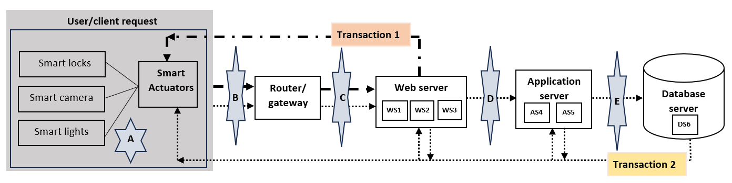
Figure 3. Transaction flows in SH architecture
We used Equations (8) – (12) for modelling breach probabilities as a convex piecewise linear function of total security countermeasure’s costs. Then, we obtained the estimates of piecewise linear function using standard least square methods with two segments are as follows:
$\left(η_{conf,1},ξ_{conf,1}\right)=\left(-0.55569, 45.84406\right), \left(η_{conf,2},ξ_{conf,2}\right)=\left(-0.51764, 45.70905\right),$
$$\left(η_{int,1},ξ_{int, 1}\right)=\left(-0.50399, 42.14079\right), \left(η_{int,2},ξ_{int, 2}\right)=\left(-0.4887, 41.60324\right),$$
$$\left(η_{avail,1},ξ_{avail, 1}\right)=\left(-0.5138, 38.36275\right), \left(η_{avail,2},ξ_{avail, 2}\right)=\left(-0.46067, 36.70002\right),$$
$$\left(η_{auth,1},ξ_{auth, 1}\right)=\left(-0.49641, 43.61062\right), \left(η_{auth,2},ξ_{auth, 2}\right)=(-0.50504, 44.20673)$$
  - Results
Now, we execute the two proposed optimization problems for the following initial case. The involved values of parameters are K = {1, 2}; L = {1: Edge layer, 2: fog layer, 3: cloud layer}; $N_{1}= \{1, 2, 3\}$, $N_{2}= \{4, 5\}$, $N_{3}=\{6\}$; S = {1: No control, 2: Network firewall, 3: Application gateway, 4: RBAC, 5: HSRP, 6: IDS/IPS, 7: MFA, 8: Network firewall+Application gateway, 9: Network firewall+ RBAC+ HSRP, 10: Network firewall+ Application gateway+ RBAC+ HSRP, 11: Network firewall+Application gateway+ RBAC+ MFA+ IDS/IPS, 12: Network firewall+ Application gateway+ RBAC+ MFA+ HSRP+IDS/IPS}; NS = {1: No control, 2: Host firewall, 3: mTLS, 4: TPM, 5: Host firewall+mTLS, 6: Host firewall+TPM+mTLS}; $C_{1}^{avail}=C_{2}^{avail}=100$; $C_{1}^{S}=0, C_{2}^{S}=$3754.08, $C_{3}^{S}=11567.95$, $C_{4}^{S}=$990.00, $C_{5}^{S}=$9239.56, $C_{6}^{S}=$6259.00, $C_{7}^{S}=$5544.00, $C_{8}^{S}=$15322.03,$C_{9}^{S}=$13983.64, $C_{10}^{S}=$25551.59, $C_{11}^{S}=$28115.03, $C_{12}^{S}=37354.59$; $C_{1}^{NS}=0, C_{2}^{NS}=1248.72, C_{3}^{NS}= 891.00, C_{4}^{NS}= 97.34, C_{5}^{NS}=2139.72, C_{6}^{NS}=2237.06; Y_{1}^{1}=30, Y_{2}^{1}=30, Y_{3}^{1}=30, Y_{4}^{2}=35, Y_{5}^{2}=35, Y_{6}^{3}=55$; $D_{1}^{SysNormal}=D_{2}^{SysNormal}=30;$ $t^{avail}= 20; γ_{d,l}^{int}=γ_{d,l}^{conf}=518,376.60 , γ_{d,l}^{auth}= 451,280.00; π_{11}=1, π_{12}=1, π_{13}=0, π_{21}=1, π_{22}=1, π_{23}=1.$ By using GlobalCybersecurity_Threats_2015-2024 dataset, the average annual confidentiality breach loss and integrity breach loss is obtained as $518,376.60, while for authentication breach, the average loss amount is $451,280.00. The list of countermeasures and their associated cost under two security settings is discussed in Appendix C. Further, we compute capacities (measured in $transactions/min$ ) of each layer of SH architecture (detailed in Appendix D) as $Y_{d}^{1}=90;$ $Y_{d}^{2}=70;Y_{d}^{3}=55.$ We, then further approximated the distribution of the error terms (detailed in Appendix E) as ln($Δ_{conf}$) ~ N(-0.0171, ${0.1832}^{2}$), ln($Δ_{int})$~ N(-0.0219, ${0.2221}^{2}$), ln($Δ_{avail}$) ~ N(-0.0100, ${0.2056}^{2}$), ln($Δ_{auth}$) ~ N(-0.0165, ${0.1784}^{2}$). Therefore, we had $E\left[Δ_{conf}\right]=0.999687$, $E\left[Δ_{int}\right]=1.002789, E\left[Δ_{auth}\right]=0.999370$. We used ln ($Δ_{avail}$) ~ N (-0.0100, 0.2056²). Phase 2 considers 100 sample, and all numerical experiments were executed in Gurobi optimizer version 12.0.3 to optimality with no optimality gaps.
The optimal solution for deterministic problem D21 is obtained as: $x_{1}^{S}=…=x_{10}^{S}=0, x_{11}^{S}=1, x_{12}^{S}=0; x_{ld1}^{Ns}=…=x_{ld5}^{Ns}=0, x_{ld6}^{Ns}=1$. Additionally, transaction rate for breached system is obtained as $D_{1}^{SysBreach}=30.00$, $D_{2}^{SysBreach}=12.05$. The output yielded the security countermeasure’s allocation at different locations is highlighted in Figure 4.
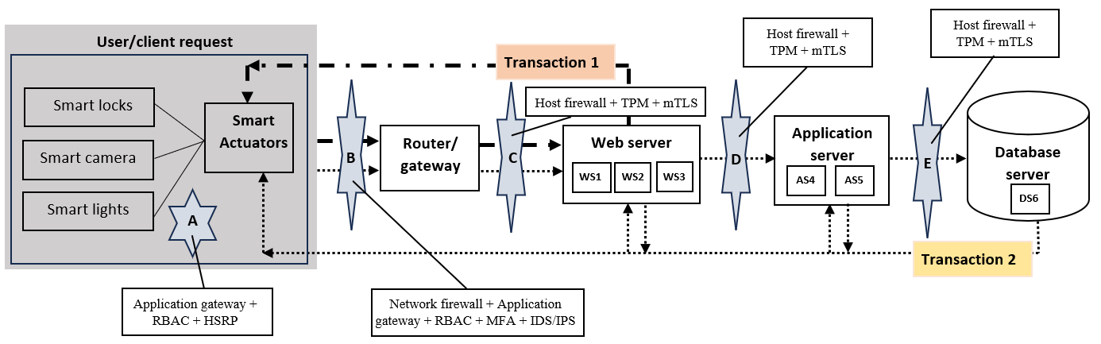
Figure 4. Security allocations at different locations in SH architecture under different transaction types
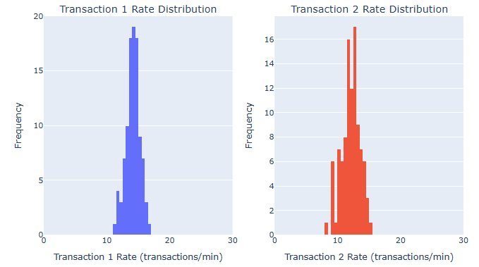
Figure 5. Empirical distributions of $D_{1θ}^{SysBreach}$ and $D_{2θ}^{SysBreach}$
For our stochastic model S2, with sample size 100, the result is obtained by employing SAA methodology. The optimal solution for P4 is obtained as: $x_{1}^{S}=…=x_{10}^{S}=0, x_{11}^{S}=1, x_{12}^{S}=0; x_{ld1}^{Ns}=…=x_{ld5}^{Ns}=0, x_{ld6}^{Ns}=1$. For a given sample $θ,$ the transaction rates under breached systems is represented by $D_{1θ}^{SysBreach}$ and $D_{2θ}^{SysBreach}$yielding an average transaction rates as $D_{1θ}^{SysBreach}=14.13$, $D_{2θ}^{SysBreach}=12.12$. The empirical distributions of $D_{1θ}^{SysBreach}$ and $D_{2θ}^{SysBreach}$are depicted in Figure 5.
Thus, under the base case parameters, the deterministic as well as stochastic model converged on the identical portfolio of security countermeasures: Network firewall + Application gateway + RBAC + MFA + IDS/IPS (under System-level security setting), Host firewall + TPM + mTLS (under Node-specific security setting). However, while the deterministic model’s output indicated expected transaction rates as: $D_{1}^{SysBreach}=30.00$, $D_{2}^{SysBreach}=12.05$, the stochastic analysis indicated that inaccuracies in breach probability estimation resulted in long-tailed distributions of expected transaction rates, implying that actual rates could drop significantly in case of $D_{2}^{\text{SysBreach}}$, to as low as 8.42. Thus, the findings underscore that errors in breach probabilities have a considerable effect on both expected losses and system transaction rates.
  - Sensitivity analysis
To validate the robustness of our models, we performed sensitivity analysis.
    - Effect of varying average losses from integrity, confidentiality, authentication breaches
Figure 6 and Figure 7 examines the effects of varying average losses from integrity, confidentiality, and authentication breaches$(γ_{d,l}^{int}, γ_{d,l}^{conf}, and γ_{d,l}^{auth})$, with other parameters at base case. Integrity breaches prove most costly due to their potential for physical harm and system manipulation. While the deterministic model suggests no investment when the losses are small, however, the stochastic model prescribes security countermeasures because availability breaches can significantly reduce transaction rates to 8.42 (Figure 5). Figure 7 shows that our stochastic model immediately recommends “Network firewall + HSRP + RBAC” indicating low tolerance for minor losses. As breach losses increases, both models converged to an effective and optimal combination of security countermeasures “(System-level setting): Network firewall + RBAC + HSRP + MFA; and (Node-specific setting): Host firewall + TPM + mTLS”. This reflects the catastrophic nature of high losses, justifying full protection. Thus, our stochastic model reflects a risk-averse approach, emphasizing uncertainty-aware cybersecurity investment decisions.
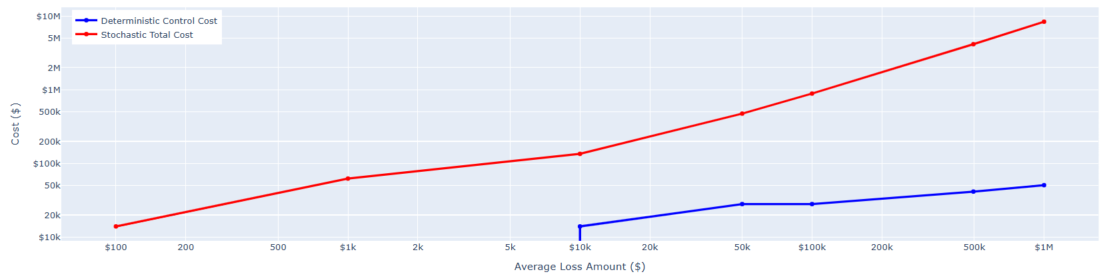
Figure 6. Effect of varying losses on security cost ($)
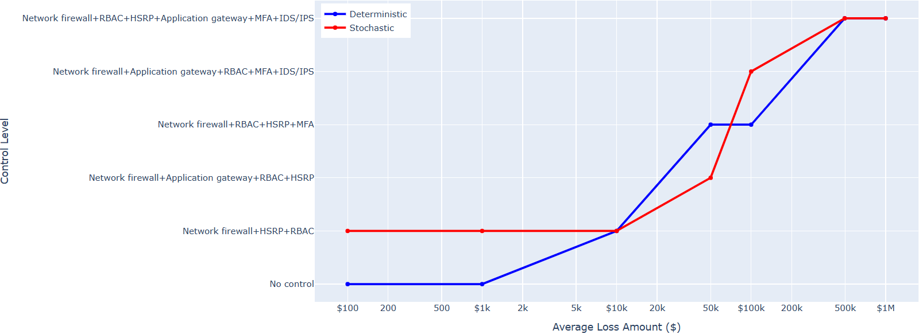
Figure 7. Effect of varying losses on countermeasure selection
    - Effect of noise in probability estimations
To test the robustness of our stochastic model against noise, we varied the standard deviation of the log-normal distribution in Equation (39*) by 110% to 150%. Across all levels, the optimal control configurations remained unchanged for all potential loss scenarios ($γ_{d,l}^{int}, γ_{d,l}^{conf}, and γ_{d,l}^{auth})$, as highlighted in Table 2. The selected control configuration is a dominant strategy for the given scenario, providing a stable and justifiable foundation for cybersecurity investment decisions.
We further validate the model by scaling the mean of the distribution as above. Table 3 results show that as mean becomes more negative, the expected values of the security attributes ${(Δ}_{conf}, Δ_{int}, and Δ_{auth})$ linearly decreases, further decreasing the expected value from 0.999687 (confidentiality (say) ) (base model: no scaling) to 0.991179 (scaling at 150%).

Table 2. Effect of varying standard deviation of noise in probability estimations
Noise parameters |  | Optimal control configuration |  | Optimal control configuration | Total Security Cost |  | System Breach Transaction rate | Estimates of conf, int, auth breach probabilities
ln(ε_conf) ~ N(-0.0171, 0.1832^2) ln(ε_int) ~ N(-0.0219, 0.2221^2)  ln(ε_avail) ~ N(-0.0100, 0.2056^2)  ln(ε_auth) ~ N(-0.0165, 0.1784^2) | $$x_{1}^{S}=…=x_{10}^{S}=0, x_{11}^{S}=1,$$  $$x_{12}^{S}=0;$$  $$x_{ld1}^{Ns}=…=x_{ld5}^{Ns}=0,$$  $$x_{ld6}^{Ns}=1$$ |  | System-specific setting=Network firewall+RBAC+HSRP+MFA Node-specific setting=Host firewall+TPM+mTLS |  | $41,537.39 | Transaction 1: 21.21 Transaction 2: 18.19 |  | u_conf=0.00004753; u_int=0.00004367; u_auth=0.00004574
ln(ε_conf)~ N(-0.0171,(1.1*0.1832)^2) ln(ε_int)~ N(-0.0219,(1.1*0.2221)^2)  ln(ε_avail)~ N(-0.0100,(1.1*0.2056)^2)  ln(ε_auth)~ N(-0.0165,(1.1*0.1784)^2) | $$x_{1}^{S}=…=x_{10}^{S}=0, x_{11}^{S}=1,$$  $$x_{12}^{S}=0;$$  $$x_{ld1}^{Ns}=…=x_{ld5}^{Ns}=0,$$  $$x_{ld6}^{Ns}=1$$ |  | System-specific setting=Network firewall+RBAC+HSRP+MFA Node-specific setting=Host firewall+TPM+mTLS |  | $41,537.39 | Transaction 1: 21.21 Transaction 2: 18.19 |  | u_conf=0.00004753; u_int=0.00004367; u_auth=0.00004574
ln(ε_conf)~ N(-0.0171,(1.2*0.1832)^2) ln(ε_int)~ N(-0.0219,(1.2*0.2221)^2)  ln(ε_avail)~ N(-0.0100,(1.2*0.2056)^2)  ln(ε_auth)~ N(-0.0165,(1.2*0.1784)^2) | $$x_{1}^{S}=…=x_{10}^{S}=0, x_{11}^{S}=1,$$  $$x_{12}^{S}=0;$$  $$x_{ld1}^{Ns}=…=x_{ld5}^{Ns}=0,$$  $$x_{ld6}^{Ns}=1$$ |  | System-specific setting=Network firewall+RBAC+HSRP+MFA Node-specific setting=Host firewall+TPM+mTLS |  | $41,537.39 | Transaction 1: 21.21 Transaction 2: 18.19 |  | u_conf=0.00004753; u_int=0.00004367; u_auth=0.00004574
ln(ε_conf) ~ N(-0.0171, (1.3*0.1832)^2) ln(ε_int) ~ N(-0.0219, (1.3*0.2221)^2)  ln(ε_avail)~ N(-0.0100, (1.3*0.2056)^2)  ln(ε_auth) ~ N(-0.0165, (1.3*0.1784)^2) | $$x_{1}^{S}=…=x_{10}^{S}=0, x_{11}^{S}=1,$$  $$x_{12}^{S}=0;$$  $$x_{ld1}^{Ns}=…=x_{ld5}^{Ns}=0,$$  $$x_{ld6}^{Ns}=1$$ |  | System-specific setting=Network firewall+RBAC+HSRP+MFA Node-specific setting=Host firewall+TPM+mTLS |  | $41,537.39 | Transaction 1: 21.21 Transaction 2: 18.19 |  | u_conf=0.00004753; u_int=0.00004367; u_auth=0.00004574
ln(ε_conf)~ N(-0.0171,(1.4*0.1832)^2) ln(ε_int)~ N(-0.0219,(1.4*0.2221)^2)  ln(ε_avail)~ N(-0.0100,(1.4*0.2056)^2)  ln(ε_auth)~ N(-0.0165,(1.4*0.1784)^2) | $$x_{1}^{S}=…=x_{10}^{S}=0, x_{11}^{S}=1, x_{12}^{S}=0; x_{ld1}^{Ns}=…=x_{ld5}^{Ns}=0, x_{ld6}^{Ns}=1$$ |  | System-specific setting=Network firewall+RBAC+HSRP+MFA Node-specific setting=Host firewall+TPM+mTLS |  | $41,537.39 | Transaction 1: 21.21 Transaction 2: 18.19 |  | u_conf=0.00004753; u_int= 0.00004367; u_auth=0.00004574
ln(ε_conf)~N(-0.0171,(1.5*0.1832)^2) ln(ε_int)~N(-0.0219,(1.5*0.2221)^2)  ln(ε_avail)~N(-0.0100,(1.5*0.2056)^2)  ln(ε_auth)~N(-0.0165,(1.5*0.1784)^2) | $$x_{1}^{S}=…=x_{10}^{S}=0, x_{11}^{S}=1, x_{12}^{S}=0; x_{ld1}^{Ns}=…=x_{ld5}^{Ns}=0, x_{ld6}^{Ns}=1$$ |  | System-specific setting=Network firewall+RBAC+HSRP+MFA Node-specific setting=Host firewall+TPM+mTLS |  | $41,537.39 | Transaction 1: 21.21 Transaction 2: 18.19 |  | u_conf=0.00004753; u_int= 0.00004367; u_auth=0.00004574

Table 3. Effect of varying mean of noise in probability estimations
Expected values | Noise parameters | Optimal control configuration | Optimal control configuration | Total Security Cost ($) | System Breach Transaction rate | Estimates of conf, int, auth breach probabilities
E[ε_conf] : 0.999687 E[ε_int] : 1.002789 E[ε_auth] : 0.999370 | ln(ε_conf) ~ N (-0.0171, 0.1832^2) ln(ε_int) ~ N(-0.0219, 0.2221^2)  ln(ε_avail) ~ N (-0.0100, 0.2056^2)  ln(ε_auth) ~ N (-0.0165, 0.1784^2) | $$x_{1}^{S}=…=x_{10}^{S}=0, x_{11}^{S}=1, x_{12}^{S}=0;$$  $$x_{ld1}^{Ns}=…=x_{ld5}^{Ns}=0, x_{ld6}^{Ns}=1$$ | System-specific setting=Network firewall+RBAC+HSRP+MFA Node-specific setting=Host firewall+TPM+mTLS | $41,537.39 | Transaction 1: 21.21 Transaction 2: 18.19 | u_conf= 0.00004753; u_int= 0.00004367; u_auth= 0.00004574
E[ε_conf] : 0.997980 E[ε_int] : 1.000599 E[ε_auth] : 0.997719 | ln(ε_conf) ~ N(1.1* (-0.0171), 0.1832^2) ln(ε_int) ~ N(1.1* (-0.0219), 0.2221^2)  ln(ε_avail) ~ N(1.1* (-0.0100), 0.2056^2)  ln(ε_auth) ~ N(1.1* (-0.0165), 0.1784^2) | $$x_{1}^{S}=…=x_{10}^{S}=0, x_{11}^{S}=1,$$  $$x_{12}^{S}=0;$$  $$x_{ld1}^{Ns}=…=x_{ld5}^{Ns}=0, x_{ld6}^{Ns}=1$$ | System-specific setting=Network firewall+RBAC+HSRP+MFA Node-specific setting=Host firewall+TPM+mTLS | $41,537.39 | Transaction 1: 21.25 Transaction 2: 19.21 | u_conf= 0.00004753; u_int= 0.00004367; u_auth= 0.00004574
E[ε_conf] : 0.996275 E[ε_int] : 0.998413 E[ε_auth] : 0.996070 | ln(ε_conf) ~ N(1.2* (-0.0171), 0.1832^2) ln(ε_int) ~ N(1.2* (-0.0219), 0.2221^2)  ln(ε_avail) ~ N(1.2* (-0.0100), 0.2056^2)  ln(ε_auth) ~ N(1.2* (-0.0165), 0.1784^2) | $$x_{1}^{S}=…=x_{10}^{S}=0, x_{11}^{S}=1,$$  $$x_{12}^{S}=0;$$  $$x_{ld1}^{Ns}=…=x_{ld5}^{Ns}=0, x_{ld6}^{Ns}=1$$ | System-specific setting=Network firewall+RBAC+HSRP+MFA Node-specific setting=Host firewall+TPM+mTLS | $41,537.39 | Transaction 1: 21.27 Transaction 2: 19.23 | u_conf= 0.00004753; u_int= 0.00004367; u_auth= 0.00004574
E[ε_conf] : 0.994574 E[ε_int] : 0.996232 E[ε_auth] : 0.994424 | ln(ε_conf) ~ N(1.3* (-0.0171), 0.1832^2) ln(ε_int) ~ N(1.3* (-0.0219), 0.2221^2)  ln(ε_avail) ~ N(1.3* (-0.0100), 0.2056^2)  ln(ε_auth) ~ N(1.3* (-0.0165), 0.1784^2) | $$x_{1}^{S}=…=x_{10}^{S}=0, x_{11}^{S}=1, x_{12}^{S}=0;$$  $$x_{ld1}^{Ns}=…=x_{ld5}^{Ns}=0, x_{ld6}^{Ns}=1$$ | System-specific setting=Network firewall+RBAC+HSRP+MFA Node-specific setting=Host firewall+TPM+mTLS | $41,537.39 | Transaction 1: 21.29 Transaction 2: 19.25 | u_conf= 0.00004753; u_int= 0.00004367; u_auth= 0.00004574
E[ε_conf] : 0.992875 E[ε_int] : 0.994056 E[ε_auth] : 0.992781 | ln(ε_conf) ~ N(1.4* (-0.0171), 0.1832^2) ln(ε_int) ~ N(1.4* (-0.0219), 0.2221^2)  ln(ε_avail) ~ N(1.4* (-0.0100), 0.2056^2)  ln(ε_auth) ~ N(1.4* (-0.0165), 0.1784^2) | $$x_{1}^{S}=…=x_{11}^{S}=0, x_{12}^{S}=1;$$  $$x_{ld1}^{Ns}=…=x_{ld5}^{Ns}=0, x_{ld6}^{Ns}=1$$ | System-specific setting=Network firewall+Application gateway +RBAC+HSRP+MFA+IDS/IPS Node-specific setting=Host firewall+TPM+mTLS | $41,537.39 | Transaction 1: 22.31 Transaction 2: 19.27 | u_conf= 0.00004775; u_int= 0.00004423; u_auth= 0.00004602
E[ε_conf] : 0.991179  E[ε_int] : 0.991884  E[ε_auth] : 0.991141 | ln(ε_conf) ~ N(1.5* (-0.0171), 0.1832^2) ln(ε_int) ~ N(1.5* (-0.0219), 0.2221^2)  ln(ε_avail) ~ N(1.5* (-0.0100), 0.2056^2)  ln(ε_auth) ~ N(1.5* (-0.0165), 0.1784^2) | $$x_{1}^{S}=…=x_{11}^{S}=0, x_{12}^{S}=1;$$  $$x_{ld1}^{Ns}=…=x_{ld5}^{Ns}=0, x_{ld6}^{Ns}=1$$ | System-specific setting=Network firewall+Application gateway + RBAC+ HSRP+MFA+IDS/IPS Node-specific setting=Host firewall+TPM+mTLS | $41,537.39 | Transaction 1: 22.35 Transaction 2: 19.29 | u_conf= 0.00004775; u_int= 0.00004423; u_auth= 0.00004602

The breached transaction rate for transaction 1 varies from 21.47 (no scaling) to 21.80 (at 150% scaling), and for transaction 2 varies from 18.54 to 18.05 (at 150% scaling). The change is primarily driven by increasing (negative) bias in the mean of ln(ε), making the model more optimistic about control effectiveness. The shift in the optimal control suite at 1.4x noise level identifies a critical decision threshold, prioritizing robustness over pure efficiency. This shows the model ability in making informed, resilient security investment decisions under uncertain and real environment.
  - Effect of varying countermeasures costs
We verify model effectiveness by varying the security countermeasure’s cost to examine the effect of changing supply chain market dynamics, considering discount (10% to 50%); and premium (10% to 50%) scenarios (Table 4). Here, the rationale behind the selection is to analyse how the impact of cost fluctuations of the security measures influences organizational decision making. Results shows that higher discounts (at 50%) reduce security costs by up to 25% in both the models while the variation in premium rates introduces greater variability. Table 4 shows that for deterministic model is extremely sensitive to price hike as it immediately drops its security posture to the bare minimum (for 20% discount or greater, the total security cost decreases from $41,544.77 to $27,696.49). In contrast, by preserving a stronger security posture, it contains the expected loss much more effectively. While selecting security countermeasures, both the models select $\{x_{12}^{S}=1; x_{ld6}^{Ns}=1\}$ (at 50% discount), and $\{x_{8}^{S}=1; x_{ld2}^{Ns}=1\}$ (at 50% price multiplier).
The analysis demonstrates that deterministic model is more cost-effective, lowering its security posture and accepting catastrophic risk, while our stochastic model proves to be more robust in security countermeasure selections, accounting for uncertainty. In conclusion, our deterministic model represents cost-effective model, and stochastic model appears to be security-effective model, thus ensuring protection against the security breaches. The variability among the security configuration is shown in Figure 8 and Figure 9.

Table 4. Effect of varying cost of security countermeasures.
Cost_ Multiplier | Deterministic | Security countermeasure’s selection |  | Stochastic
 | Objective value (Annual optimal security cost) |  |  | Objective value (Annual optimal security cost)
(-) 50% | $3,876,295.18 ($27,696.49) | $$x_{1}^{S}=…=x_{11}^{S}=0, x_{12}^{S}=1;$$  $$x_{ld1}^{Ns}=…=x_{ld5}^{Ns}=0, x_{ld6}^{Ns}=1$$ |  | $4,731,977.43 ($27,696.51)
(-) 40% | $3,863,917.33 ($32,312.58) | $$x_{1}^{S}=…=x_{11}^{S}=0, x_{12}^{S}=1;$$  $$x_{ld1}^{Ns}=…=x_{ld5}^{Ns}=0, x_{ld6}^{Ns}=1$$ |  | $4,756,324.44 ($32,312.58)
(-) 30% | $3,851,539.49 ($36,928.68) | deterministic model  $$x_{1}^{S}=…=x_{11}^{S}=0,$$  $$x_{12}^{S}=1; x_{ld1}^{Ns}=…=x_{ld5}^{Ns}=0, x_{ld6}^{Ns}=1$$ | stochastic model  $$x_{1}^{S}=…=x_{10}^{S}=0, x_{11}^{S}=1, x_{12}^{S}=0; x_{ld1}^{Ns}=…=x_{ld5}^{Ns}=0, x_{ld6}^{Ns}=1$$ | $4,737,114.58 ($30,209.00)
(-) 20% | $3,839,156.98 ($41,544.77) | deterministic model  $$x_{1}^{S}=…=x_{11}^{S}=0, x_{12}^{S}=1; x_{ld1}^{Ns}=…=x_{ld5}^{Ns}=0, x_{ld6}^{Ns}=1$$ | stochastic model  $$x_{1}^{S}=…=x_{10}^{S}=0, x_{11}^{S}=1, x_{12}^{S}=0; x_{ld1}^{Ns}=…=x_{ld5}^{Ns}=0, x_{ld6}^{Ns}=1$$ | $4,756,017.14 ($33,985.13)
(-) 10% | $3,858,043.02 ($37,761.26) | $x_{1}^{S}=…=x_{10}^{S}=0, x_{11}^{S}=1, x_{12}^{S}=0; x_{ld1}^{Ns}=…=x_{ld5}^{Ns}=0, x_{ld6}^{Ns}=1$ |  | $4,774,919.72 ($37,761.26)
Base parameters | $ 4,152,505.70 ($41,537.39) | $$x_{1}^{S}=…=x_{10}^{S}=0, x_{11}^{S}=1, x_{12}^{S}=0;$$  $$x_{ld1}^{Ns}=…=x_{ld5}^{Ns}=0, x_{ld6}^{Ns}=1$$ |  | $4,160,346.39 ($41,537.39)
(+) 10% | $4,249,668.72 ($41,219.90) | $$x_{1}^{S}=…=x_{9}^{S}=0, x_{10}^{S}=1, x_{1}^{S}=x_{12}^{S}=0;$$  $$x_{ld1}^{Ns}=x_{ld4}^{Ns}=0, x_{ld5}^{Ns}=1, x_{ld6}^{Ns}=0$$ |  | $4,792,116.27 ($41,219.90)
(+) 20% | $4,690,405.77 ($22,844.12) | deterministic model  $$x_{1}^{S}=…=x_{8}^{S}=0,$$  $$x_{9}^{S}=1, x_{10}^{S}=x_{12}^{S}=0;$$  $$x_{ld1}^{Ns}=x_{ld2}^{Ns}=0,x_{ld3}^{Ns}=1, x_{ld4}^{Ns}=x_{ld6}^{Ns}=0$$ | stochastic model  $$x_{1}^{S}=…=x_{7}^{S}=0, x_{8}^{S}=1,$$  $$x_{9}^{S}=x_{12}^{S}=0;$$  $$x_{ld1}^{Ns}=x_{ld4}^{Ns}=0, x_{ld5}^{Ns}=1,$$  $$x_{ld6}^{Ns}=0$$ | $4,732,305.53 ($35,280.42)
(+) 30% | $4,585,779.06 ($24,601.36) | deterministic model  $$x_{1}^{S}=…=x_{7}^{S}=0,$$  $$x_{8}^{S}=1, x_{9}^{S}=x_{12}^{S}=0;$$  $$x_{ld1}^{Ns}=x_{ld2}^{Ns}=0,x_{ld3}^{Ns}=1, x_{ld4}^{Ns}=x_{ld6}^{Ns}=0$$ | stochastic model  $$x_{1}^{S}=…=x_{7}^{S}=0, x_{8}^{S}=1, x_{9}^{S}=x_{12}^{S}=0; x_{ld1}^{Ns}=x_{ld4}^{Ns}=0, x_{ld5}^{Ns}=1, x_{ld6}^{Ns}=0$$ | $4,743,567.24 ($35,840.45)
(+) 40% | $4,574,982.60 ($31,110.48) | $$x_{1}^{S}=…=x_{7}^{S}=0, x_{8}^{S}=1, x_{9}^{S}=x_{12}^{S}=0;$$  $$x_{ld1}^{Ns}=0,x_{ld3}^{Ns}=x_{ld6}^{Ns}=0, x_{ld2}^{Ns}=1$$ |  | $4,740,878.94 ($31,110.48)
(+) 50% | $4,569,945.51 ($31,184.51) | $$x_{1}^{S}=…=x_{7}^{S}=0, x_{8}^{S}=1, x_{9}^{S}=x_{12}^{S}=0;$$  $$x_{ld1}^{Ns}=…=x_{ld3}^{Ns}=x_{ld6}^{Ns}=0, x_{ld2}^{Ns}=1$$ |  | $4,751,211.26 ($33,184.51)
Note: Discounted rate (represented with (-)), and premium rate (represented with (+)).

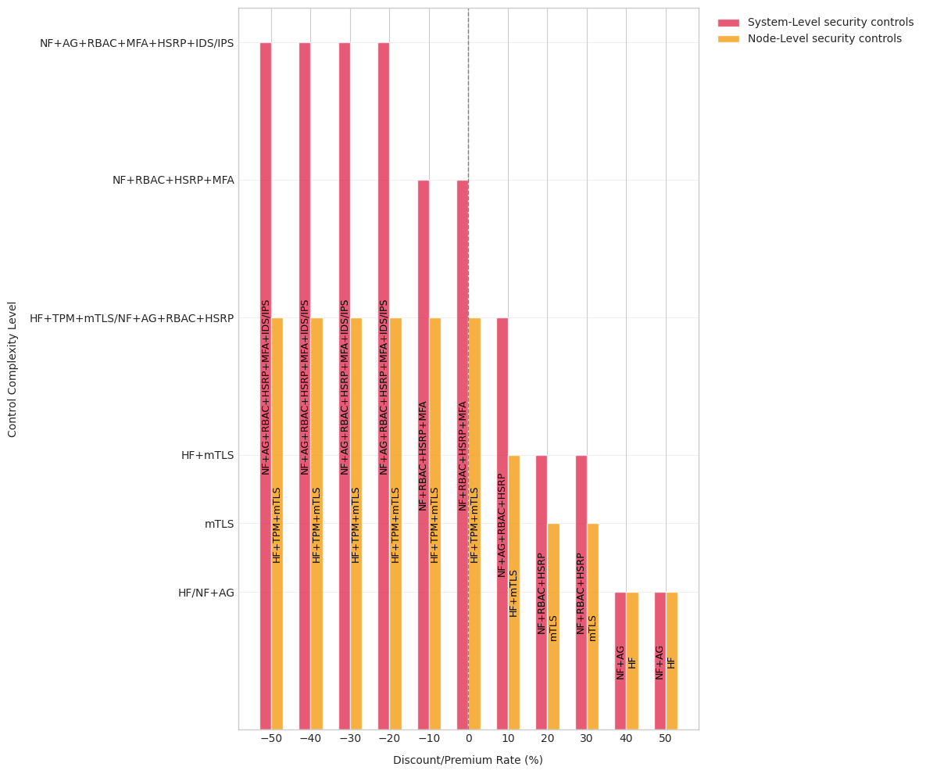
Figure 8. Effect of varying cost (discounted/premium) on control selection for deterministic model
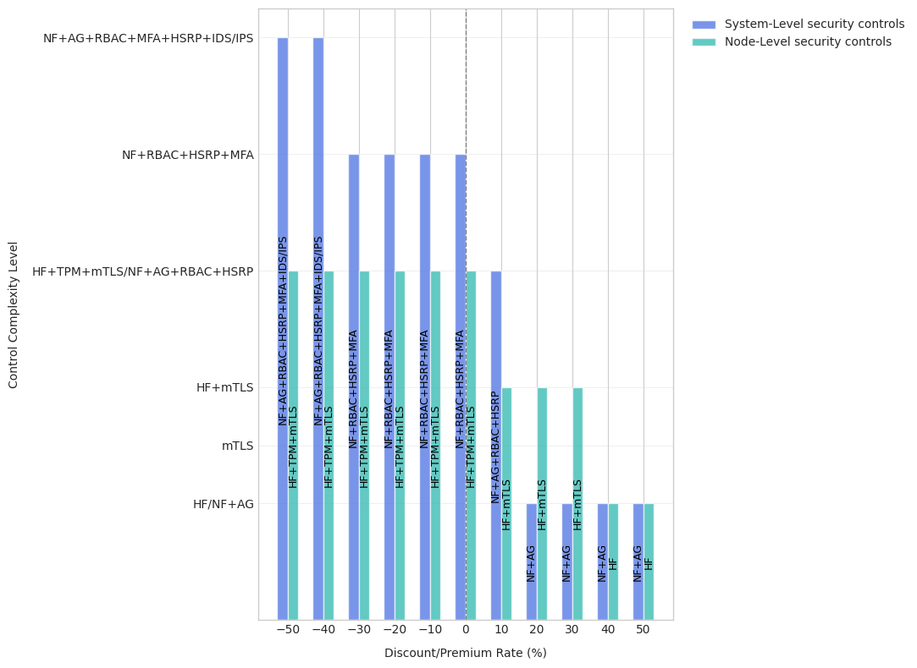
Figure 9. Impact of varying cost (discounted/premium) on control selection for stochastic model
- Managerial Implications
The results of our study provide valuable insights for various stakeholders accountable for securing smart home and IoT infrastructures.
First, IT security leaders and product managers should recognize that breach impacts often follow long-tail distributions, meaning that real-world consequences can be significantly more severe than deterministic predictions suggest. The stochastic model developed here identifies a layered defense-in-depth strategy comprising of system-level (Network Firewall, Application Gateway, RBAC, MFA, IDS/IPS) and node-level (Host Firewall, TPM, mTLS) countermeasures that addresses the expanded CIAA threat landscape. Deploying this integrated configuration enables organizations to strengthen resilience and maintain trust even under security breaches.
Second, our analysis reveals that security investment is a non-linear, threshold-driven process, which has profound implications for budget justification and resource allocation. When potential losses are perceived as low, deterministic models may suggest minimal investment. However, when potential losses surpass a critical financial and operational threshold, a comprehensive investment in robust optimal security countermeasures becomes imperative. This highlights the importance of accurately quantifying the potential financial impact of security breaches including intangible costs such as reputational damage, loss of customer trust, and significant operational disruption. Consequently, the stochastic model advanced in this study provides a rigorous analytical framework capable of generating empirically grounded business cases, thereby facilitating informed decision-making by executive leadership and board members for budget approval and strategic prioritization.
Third, this study delivers procurement managers and financial decision-makers with tactical tools for leveraging market dynamics. Analyzing discount and premium rates on security control costs demonstrates that strategic procurement reduces security costs by 25%, presenting a valuable opportunity for cost-saving. However, the key insight is that these market fluctuations should not alter the fundamental architectural strategy. The stochastic model's selections remained consistent across cost variations, proving their robustness. Managers should capitalize on market discounts to acquire the predefined optimal countermeasures at lower cost, rather than opting for suboptimal solutions based solely on price.
Finally, for policymakers and strategic planners, the study demonstrates that robustness and consistency in security planning outweigh short-term cost considerations. While the deterministic model might appear economically attractive in static scenarios, their recommendations are highly sensitive to input variations, making them unreliable for long-term strategy. In contrast, the stochastic model's selections are robust to significant noise in probability estimations and remain consistent across a wide range of loss values and market costs. The marginally higher investment required for stochastic-derived solutions is an investment in strategic stability and operational resilience, ensuring that security measures serve as a durable shield rather than a variable expense. This enables organizations to confidently safeguard their assets and reputation under cyberthreat landscape.
- Conclusion
This study proposes a comprehensive framework for optimizing cybersecurity investments in SH environments, by extending the CIA triad to incorporate authentication. Proposed two-stage stochastic optimization model is solved using Sample Average Approximation (SAA) and validated with real-world cost and simulated data for breach probabilities. Finding shows that stochastic model outperforms deterministic model by effectively prioritizing high-impact risks, thus improving robustness to estimation errors and market fluctuations. Results provide actionable assistance for designing strategic resilient SH security strategies.
Despite its contributions, the study acknowledges limitations. First, breach loss parameters are derived from a finite dataset, limiting generalizability across contexts. Second, security costs and threat data are treated as a static snapshot (2014–2024), whereas markets and attacks evolve dynamically. Third, reliance on log-normal distributions and SAA reflects modeling choices that may affect outcomes. These limitations suggest multiple avenues for future research. Longitudinal studies could be conducted that continuously update breach and cost data, integrating adaptive threat dynamics, and incorporating emerging technologies like AI-based anomaly detection or blockchain authentication. Further, expanding methodological scope through distributionally robust optimization or fuzzy programming could further enhance resilience, advancing both theoretical and practical insights into IoT based smart ecosystems.
References
Bastos D., Shackleton M., El-Moussa F. (2018). Internet of things: A survey of technologies and security risks in smart home and city environments; Proceedings of the Living in the Internet of Things: Cybersecurity of the IoT-2018; London, UK. 28–29 March, 30–37. https://doi.org/10.1049/cp.2018.0030
Bertsimas, D., and Tsitsiklis, J. N. 1997. Introduction to linear optimization, 6, 479-530. Belmont, MA: Athena scientific.
Bomze, I. M., Schachinger, W., and Ullrich, R. (2018). The complexity of simple models—a study of worst and typical hard cases for the standard quadratic optimization problem.” Mathematics of Operations Research, 43(2), 651-674. https://doi.org/10.1287/moor.2017.0877
Bomze, I., and Gabl, M. 2022. Uncertainty preferences in robust mixed-integer linear optimization with endogenous uncertainty.” SIAM Journal on Optimization, 32(1), 292-318. https://doi.org/10.1137/20M1355422
Fakhri D, Mutijarsa K. (2018). Secure IoT communication using blockchain technology.” In: 2018 International Symposium on Electronics and Smart Devices (ISESD), 1–6. IEEE. https://doi.org/10.1109/ISESD.2018.8605485
Fayard, N., Ríos Insua, D., and Tsoukiàs, A. (2025). A framework for expected capability sets. Annals of Operations Research, 1-27. https://doi.org/10.1007/s10479-025-06793-4
Gordon, L. A., and Loeb, M. P. (2002). The economics of information security investment. ACM Transactions on Information and System Security (TISSEC), 5(4), 438-457. https://doi.org/10.1145/581271.581274
Gordon, L. A., Loeb, M. P., and Zhou, L. (2011). The impact of information security breaches: Has there been a downward shift in costs? Journal of Computer Security, 19(1), 33-56. https://doi.org/10.3233/JCS-2009-0398
Grass, E., Pagel, C., Crowe, S., and Ghafur, S. (2025). A stochastic optimisation model to support cybersecurity within the UK national health service. Journal of the Operational Research Society, 76(7), 1379-1390. https://doi.org/10.1080/01605682.2024.2436063
Hausken, K. (2006). Returns to information security investment: The effect of alternative information security breach functions on optimal investment and sensitivity to vulnerability. Information Systems Frontiers, 8(5), 338-349. https://doi.org/10.1007/s10796-006-9011-6
Highleyman, B. (2003). Breaking the Availability Barrier: Survivable Systems for Enterprise Computing (Vol. 1). Authorhouse.
Jungebloud, T., Nguyen, N. H., Kim, D. D., and Zimmermann, A. (2025). Model-based structural and behavioural cybersecurity risk assessment in system designs. Computers & Security, 104543. https://doi.org/10.1016/j.cose.2025.104543
Kaur, H., Gupta, M., and Singh, S. P. (2024). Integrated model to optimize supplier selection and investments for cyber resilience in digital supply chains. International Journal of Production Economics, 275, 109338. https://doi.org/10.1016/j.ijpe.2024.109338
Khouzani, M. H. R., Liu, Z., and Malacaria, P. (2019). Scalable min-max multi-objective cyber-security optimisation over probabilistic attack graphs. European Journal of Operational Research, 278(3), 894-903. https://doi.org/10.1016/j.ejor.2019.04.035
Keith, K., Castillo-Villar, K. K., and Bhuiyan, T. H. (2024). Attack graph-based stochastic modeling approach for enabling cybersecure semiconductor wafer fabrication. Computers & Industrial Engineering, 188, 109912. https://doi.org/10.1016/j.cie.2024.109912
Kim, S., Pasupathy, R., and Henderson, S. G. (2014). A guide to sample average approximation. Handbook of simulation optimization, 207-243. https://doi.org/10.1007/978-1-4939-1384-8_8
Mitev, R., Miettinen, M., and Sadeghi, A. R. (2019). Alexa lied to me: Skill-based man-in-the-middle attacks on virtual assistants. In Proceedings of the 2019 ACM Asia Conference on Computer and Communications Security, 465-478. https://doi.org/10.1145/3321705.3329842
Paul, J. A., and Zhang, M. 2021. Decision support model for cybersecurity risk planning: A two-stage stochastic programming framework featuring firms, government, and attacker. European Journal of Operational Research, 291(1), 349-364. https://doi.org/10.1016/j.ejor.2020.09.013
Ruszczyński, A., and Shapiro, A. (2003). Stochastic programming models.” Handbooks in operations research and management science, 10, 1-64. https://doi.org/10.1016/S0927-0507(03)10001-1
Sawik, T. (2022). A linear model for optimal cybersecurity investment in Industry 4.0 supply chains. International Journal of Production Research, 60(4), 1368-1385. https://doi.org/10.1080/00207543.2020.1856442
Sawik, T., and Sawik, B. (2022). A rough cut cybersecurity investment using portfolio of security controls with maximum cybersecurity value. International Journal of Production Research, 60(21), 6556-6572. https://doi.org/10.1080/00207543.2021.1994166
Schilling, A., and Werners, B. (2016). Optimal selection of IT security safeguards from an existing knowledge base. European Journal of Operational Research, 248(1), 318-327. https://doi.org/10.1016/j.ejor.2015.06.048
Shukla, M., Sarmah, S. P., and Tiwari, M. K. (2023). A multi-objective framework for the identification and optimisation of factors affecting cybersecurity in the Industry 4.0 supply chain. International Journal of Production Research, 61(15), 5266-5281. https://doi.org/10.1080/00207543.2022.2100840
Smart Home Market Size, Share & Trends Report, 2024. https://www.marketsandmarkets.com/Market-Reports/smart-homes-and-assisted-living-advanced-technologie-and-global-market-121.html . Accessed on 17th July 2024.
Touqeer, H., Zaman, S., Amin, R., Hussain, M., Al-Turjman, F., and Bilal, M. (2021). Smart home security: challenges, issues and solutions at different IoT layers. The Journal of Supercomputing, 77(12), 14053-14089. https://doi.org/10.1007/s11227-021-03825-1
U.S. Code, U.S. Code, (2000), p. 44 http://www.gpoaccess.gov/uscode/. Accessed on 5September 2024.
Wang, Z. (2019). Identity-based verifiable aggregator oblivious encryption and its applications in smart grids. IEEE Transactions on Sustainable Computing, 6(1), 80-89. https://doi.org/10.1109/TSUSC.2019.2905040
Zhang, H., Chari, K., and Agrawal, M. (2018). Decision support for the optimal allocation of security controls. Decision Support Systems, 115, 92-104. https://doi.org/10.1016/j.dss.2018.10.001
Zhang, Y., Malacaria, P., Loukas, G., and Panaousis, E. (2023). CROSS: A framework for cyber risk optimisation in smart homes. Computers & Security, 130, 103250. https://doi.org/10.1016/j.cose.2023.103250
Zhang, Y., and Malacaria, P. (2025). Dealing with uncertainty in cybersecurity decision support. Computers & Security, 148, 104153. https://doi.org/10.1016/j.cose.2024.104153
Zheng, L., Chen, Y., Liu, G., and Bao, J. (2025). A unified robust optimization approach for problems with costly simulation-based objectives and constraints. Computers & Operations Research, 107179. https://doi.org/10.1016/j.cor.2025.107179
Additional references
AWS EC2 Cost Comparison Calculator: https://awsmedia.s3.amazonaws.com/User_Guide_Amazon_EC2_Cost_Comparison_Calculator.pdf. Accessed on 17 April 2025.
Nieles, M., Dempsey, K., and Pillitteri, V. Y. (2017). An introduction to information security. NIST special publication 800(12), 101. https://nvlpubs.nist.gov/nistpubs/SpecialPublications/NIST.SP.800-12r1.pdf

